E1

- As shown in the scatterplots below, first of all, the relationship is not linear. The Highway MPG drops as the horsepower increases, and the drop is especially sharp when horsepower is between 50 and 100. When horsepower exceed 100, the drop becomes less sharp. When horsepower is larger than 200, the relationship fluctuates, with 300 horsepower actually having higher Highway MPG than 200.
- Similarities: both LOESS line and B-spline captures the general pattern of the data, especially the negative relationship between horsepower and highway MPG when horsepower is between 50 and 100.
- Differences: The b-spline is smoother than the LOESS line.
The b-spline has a wider 95% CI compared with LOESS line when horsepower is high (higher than 200).
Also, when horsepower is between 50 and 200, the LOESS line fits more accurately, and reflects some fluctuations that are not shown by the b-spline. However, when the horsepower exceeds 200, the b-spline captures the pattern of the last 2 points, where higher horsepower is associated with higher Highway MPG.

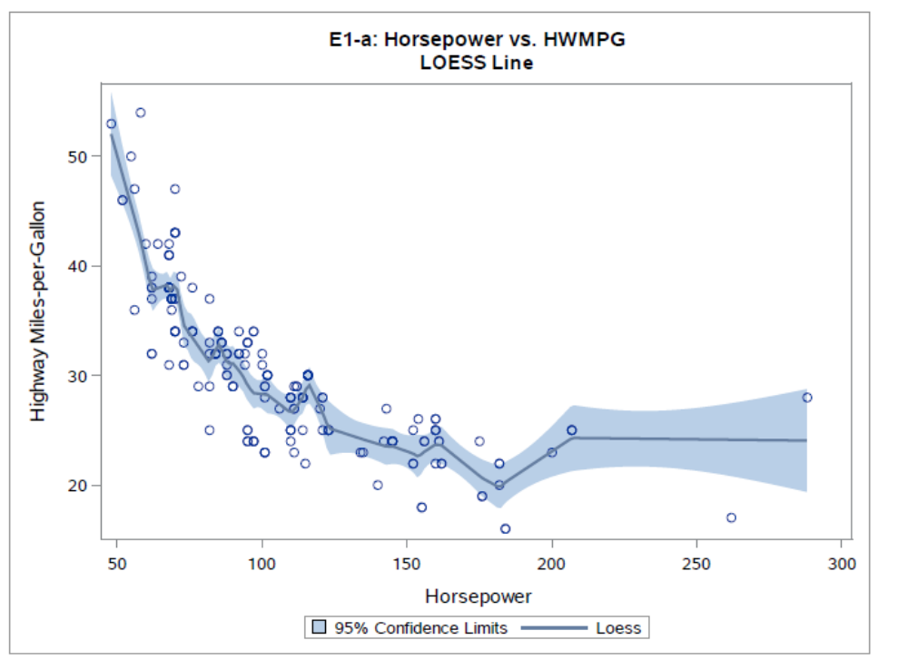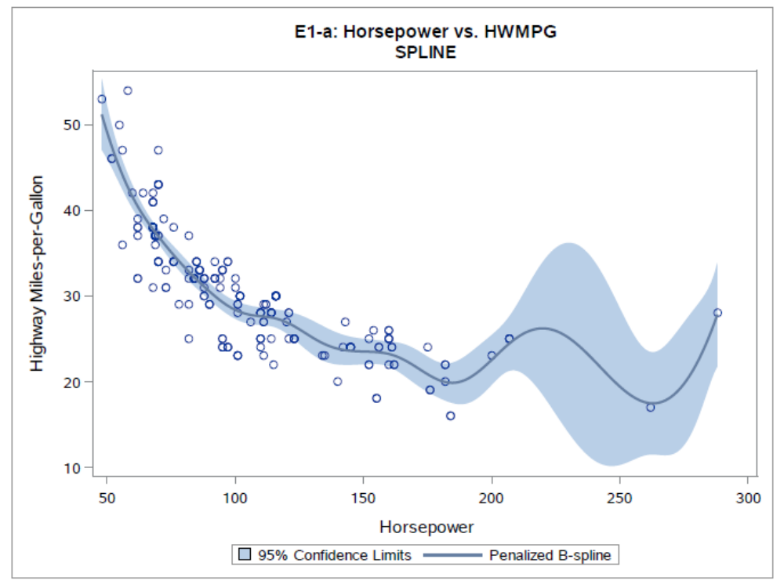

- t-test: As is shown below, the linear effect of horsepower is statistically significant (t-value=-25.82, p-value<.0001).
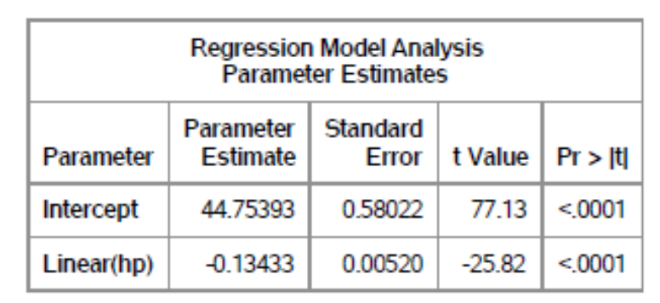
- Chi-square test: As is shown below, the nonparametric horsepower effect is statistically significant (chi-square value=270.3, p-value<.0001).
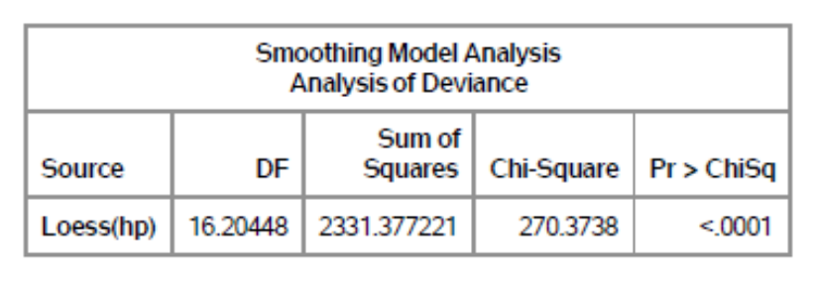

- As is shown below, the linear horsepower effect is still statistically significant (t-value=23.99, p-value<.0001).
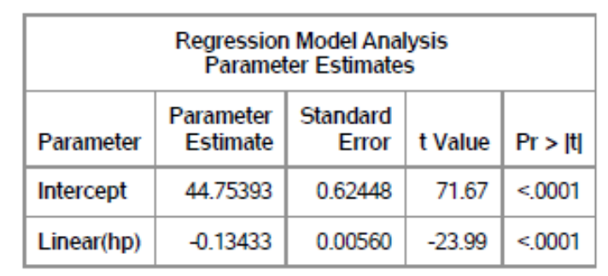
- As is shown below, the nonparametric horsepower effect is also statistically significant (chi-square value=194.49, p-value<.0001).
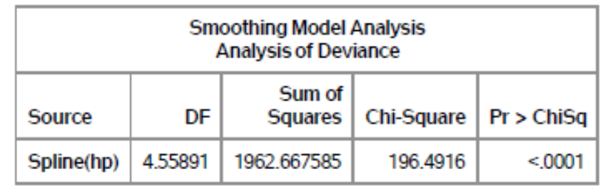

- As is shown below, the relationship between Highway MPG and horsepower is generally negative, but at the same time nonlinear.
- The spline is smoother than the LOESS line.
- Both solutions show statistically significant nonparametric effect of horsepower on Highway MPG. LOESS solution has larger absolute value of t-value and larger chi-square value compared with spline solution.
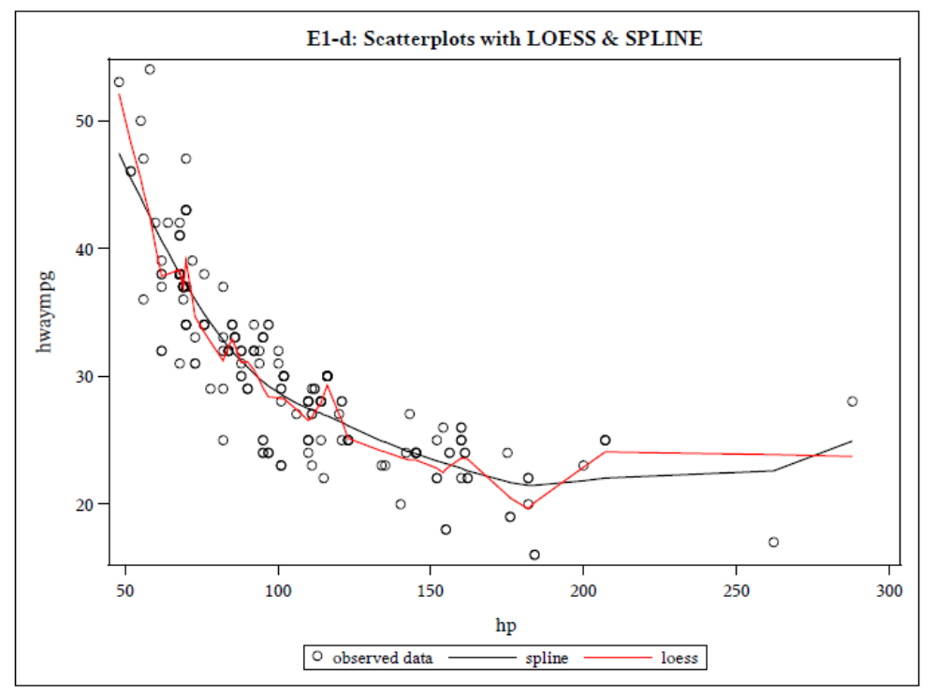

E2

- According to the table below, Type 1 has the lowest errors mean (3.63), while Type 4 has the highest (6.63). However, the 2 types have the same variance (5.41), which is also the largest among the 4 types.
- Type 2 and Type 3 have almost the same mean values (4.25 and 4.38), but the variances are very different, with Type 2 having much higher a variance (4.50) than Type 3 (1.70).
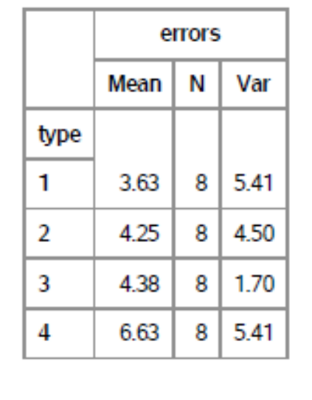

- As is shown below, given that subject is included in the model, type of altimeter has a statistically significant effect on numbers of reading errors (F-value=9.36, p-value=0.0004).
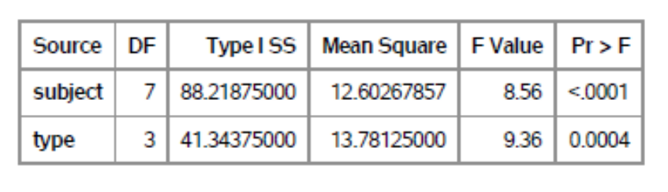
As is shown below, Type 4 is significantly different from all the other 3 types, but Type 1, 2, and 3 are not significantly difference from each other. The same conclusion can be drawn by looking at the second table (p-values=.0004, 0.0041, and 0.0007).
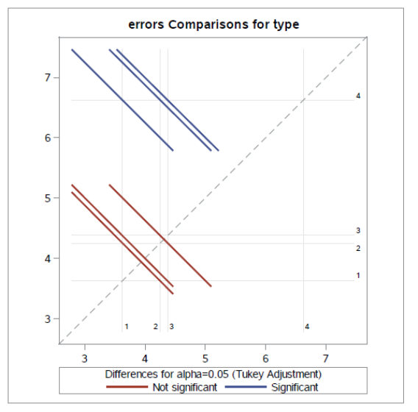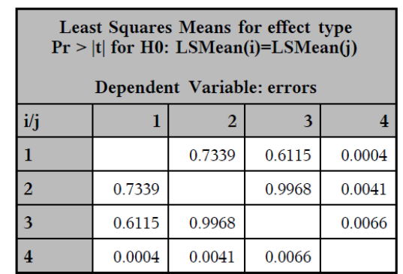

- The tables below show that
- In terms of reading error numbers, Type 1 and Type 4 have statistically significant mean difference (F-value=14.82, p-value=.006).
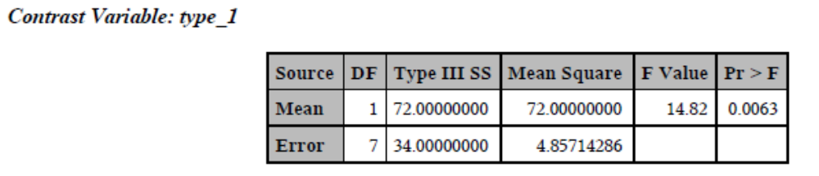
- In terms of reading error numbers, Type 2 and Type 4 have statistically significant mean difference (F-value=7.92, p-value=.026).
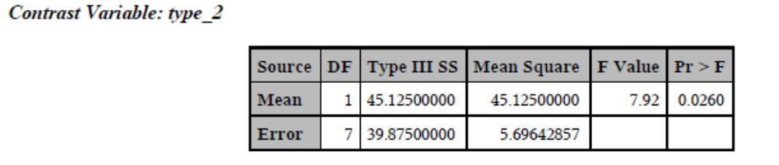
- In terms of reading error numbers, Type 2 and Type 4 have statistically significant mean difference (F-value=13.19, p-value=0.0084).
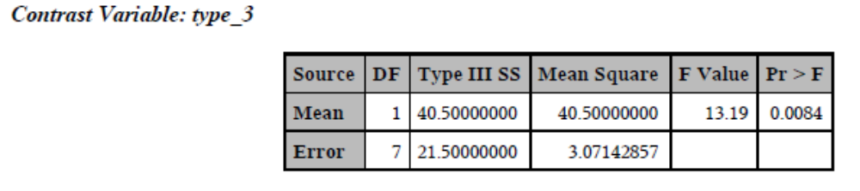
This is consistent with what we got from the Tukey’s pairwise comparison from E2-b.

